TASK 4 – EXPLOITATION & SYSTEM SECURITY
1. INTRODUCTION
Cybersecurity requires organizations to continuously identify vulnerabilities, understand possible attack techniques, and implement appropriate security controls. Penetration testing is a controlled security-testing methodology used to identify weaknesses in systems and evaluate their security posture.
This task focuses on penetration-testing methodology, exploitation concepts, password attacks, social-engineering awareness, malware analysis, and system hardening. All practical activities were performed in a controlled cybersecurity laboratory environment using Kali Linux.

2. OBJECTIVE
The main objectives of this task are:
- To understand the penetration-testing workflow.
- To perform reconnaissance and network scanning.
- To understand exploitation using the Metasploit Framework.
- To demonstrate controlled password attacks using Hydra and John the Ripper.
- To create a safe phishing-awareness simulation.
- To understand static and dynamic malware analysis.
- To apply basic system-hardening techniques.
- To document security findings and corresponding mitigations.

3. LAB ENVIRONMENT
Operating System
Kali Linux
Tools Used
- Nmap
- Metasploit Framework
- Hydra
- John the Ripper
- UFW
- Apache2
- Linux command-line utilities
Target Environment
A controlled local cybersecurity laboratory environment was used for testing. Testing was restricted to systems under the student's control.
Kali Linux IP Address
10.0.2.15
Insert the screenshot where you obtained:
10.0.2.15/24

4. PENETRATION TESTING METHODOLOGY
The penetration-testing methodology consists of the following stages:
Reconnaissance → Scanning → Exploitation → Post-Exploitation → Reporting
4.1 Reconnaissance
Reconnaissance is the first stage of penetration testing. The objective is to identify information about the target environment, such as IP addresses, available systems, and network configuration.
In this task, the local Kali Linux network configuration was examined and the system IP address was identified as:
10.0.2.15

4.2 Scanning
Nmap was used to identify available services and gather information about the local test environment.
A service-version scan was performed using:
nmap -sV 10.0.2.15
The scan helps identify open ports, running services, and service versions that may require further security assessment.
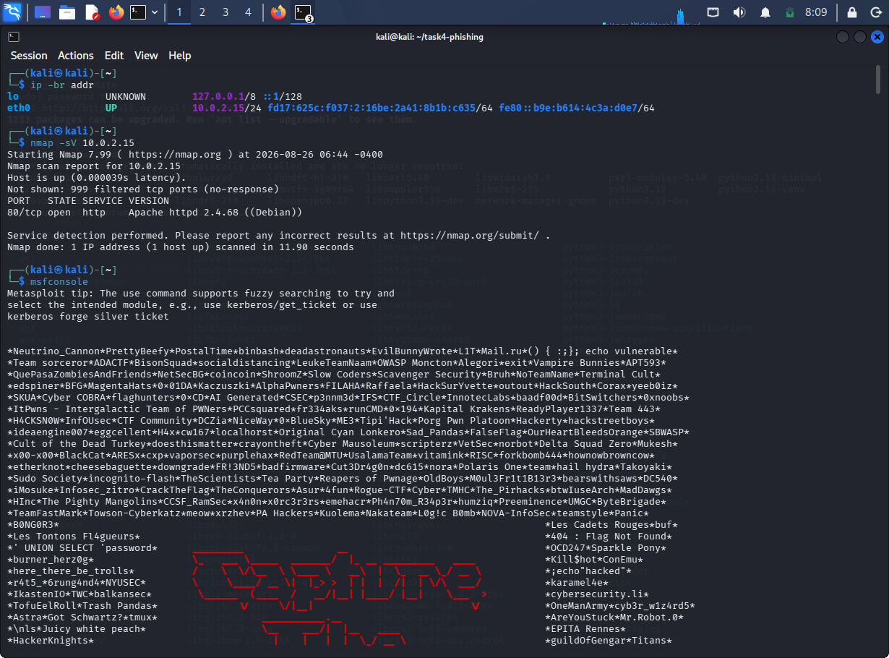

4.3 Exploitation
The exploitation phase attempts to use an identified vulnerability in a controlled environment to demonstrate its security impact.
The Metasploit Framework was launched in Kali Linux:
msfconsole
Metasploit modules were researched for potential vulnerabilities and exploitation scenarios.
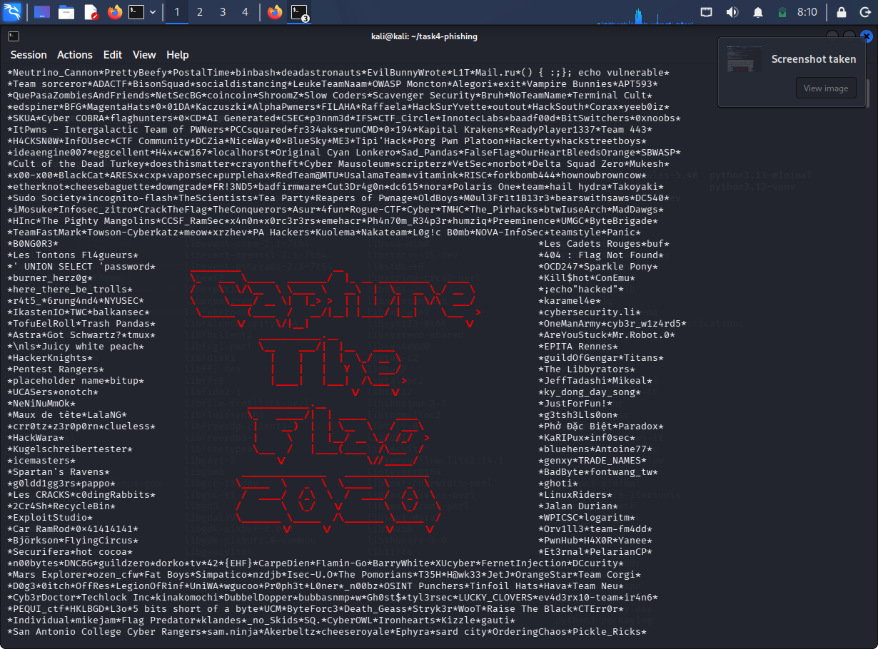

Note: The specific Metasploitable2 exploitation requirement requires a separate Metasploitable2 vulnerable target. It was not available in the current Kali-only environment, so no false successful exploitation result is reported.

4.4 Post-Exploitation
Post-exploitation is performed after successfully obtaining access to a vulnerable target. Typical activities include identifying the compromised system and gathering authorized security information.
Examples of Metasploit post-exploitation commands required by the task include:
sysinfo
hashdump
These commands were not claimed as successfully executed because the required vulnerable Metasploitable2 target was unavailable.

4.5 Reporting
The final stage involves documenting:
- Security observations
- Tools used
- Test procedures
- Results
- Evidence
- Security risks
- Recommended mitigations
This report provides the documentation for the activities performed during Task 4.

5. EXPLOITATION WITH METASPLOIT
5.1 Introduction
Metasploit Framework is a penetration-testing platform that provides modules for vulnerability research, exploitation, payload generation, and post-exploitation.
The framework was successfully launched in Kali Linux.
Command:
msfconsole
Various modules were researched to understand how known vulnerabilities can be tested in an authorized laboratory.
5.2 Metasploitable2 Requirement
The task requires exploitation of a known vulnerability in Metasploitable2, followed by obtaining a reverse shell and performing post-exploitation using sysinfo and hashdump.
Because Metasploitable2 was not available as a separate vulnerable target during this Kali-only session, the successful exploitation and reverse-shell results are not fabricated in this report.
Security Mitigation
Known vulnerable services should be:
- Patched regularly.
- Removed when unnecessary.
- Restricted using firewall rules.
- Monitored for suspicious activity.
- Replaced with secure versions where possible.

6. PASSWORD ATTACKS
Password attacks demonstrate the importance of strong authentication and password policies.
Two tools were studied:
- Hydra
- John the Ripper

6.1 SSH Brute-Force Demonstration Using Hydra
Hydra is a password-testing tool that can test credentials against supported network services.
A dedicated local test account was created for the controlled demonstration.
A small password wordlist was created containing test passwords.
Example:
password
123456
Task4@123
admin
Hydra was then used against the local SSH test service.
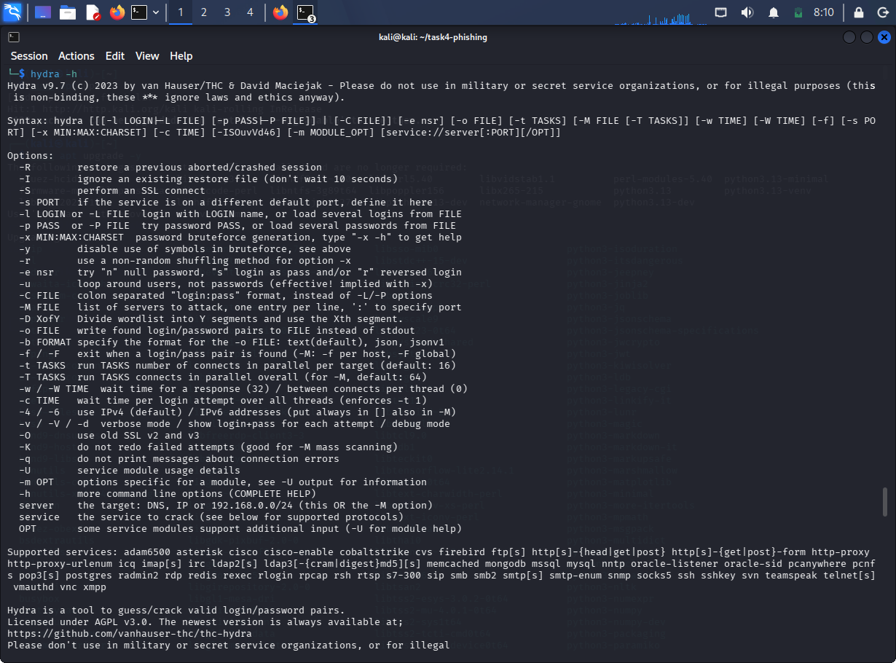

Observation
The demonstration showed how weak passwords can potentially be discovered when they are present in a password list.
Mitigation
Organizations should use:
- Strong passwords.
- Account lockout policies.
- Multi-factor authentication.
- SSH key authentication.
- Rate limiting.
- Monitoring of failed login attempts.

6.2 Password Hash Cracking Using John the Ripper
John the Ripper is a password-security auditing tool that can test password hashes against dictionaries and other cracking techniques.
A controlled password hash was prepared for the laboratory demonstration.
The password wordlist was:
password
123456
Task4@123
admin
John the Ripper was used to test the hash against the wordlist.
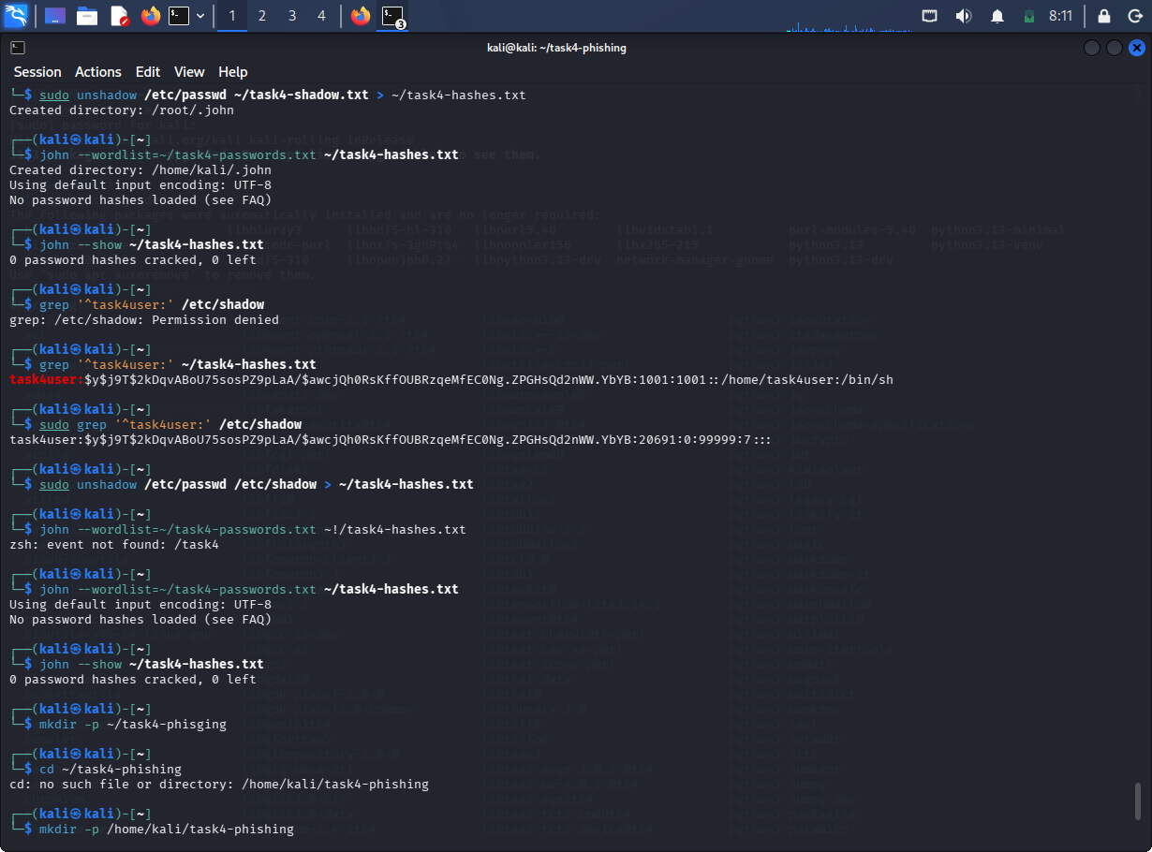
Observation
Password-hash cracking demonstrates that weak passwords can be vulnerable to dictionary-based attacks.
Mitigation
Password security can be improved by:
- Using long, unique passwords.
- Using strong password-hashing algorithms.
- Using salted password hashes.
- Enabling MFA.
- Preventing password reuse.
- Monitoring authentication attempts.

7. SOCIAL ENGINEERING – PHISHING AWARENESS SIMULATION
7.1 Introduction
Social engineering attacks attempt to manipulate users into revealing information or performing unsafe actions.
For this task, a safe phishing-awareness simulation was created locally.
The simulation did not collect real passwords or personal information.
The page explained common warning signs of phishing.
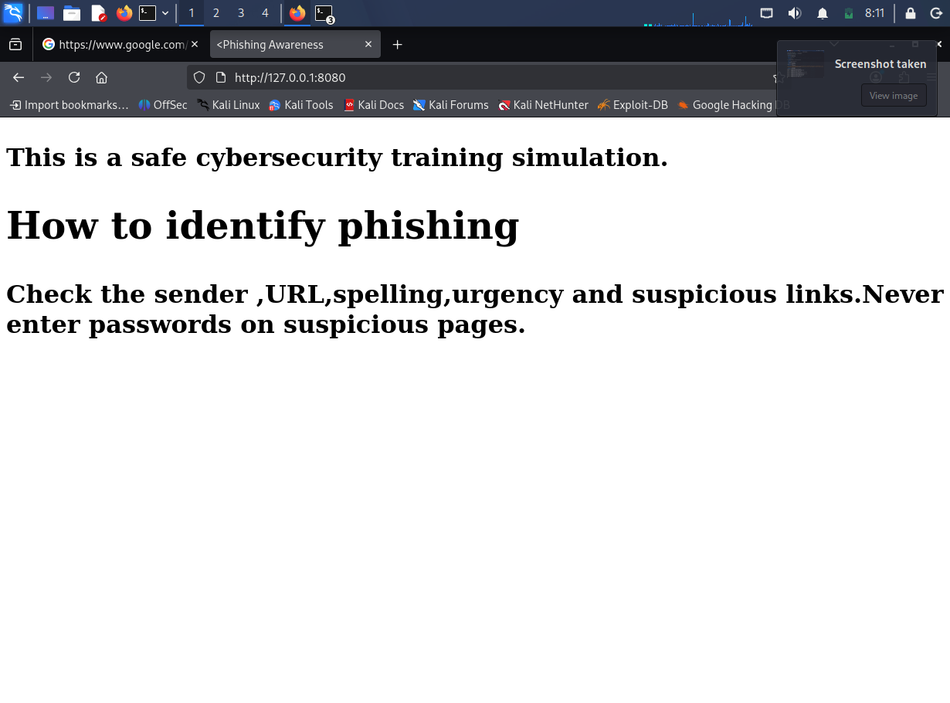
7.2 Phishing Warning Signs
Users should check:
- Sender address.
- Website URL.
- Spelling and grammar.
- Unexpected attachments.
- Urgent requests.
- Suspicious links.
- Requests for passwords or sensitive information.
7.3 Mitigation
Organizations can reduce phishing risk through:
- Security-awareness training.
- Email filtering.
- Multi-factor authentication.
- URL protection.
- Regular phishing simulations.
- User reporting mechanisms.

8. MALWARE BASICS
8.1 Introduction
Malware is malicious software designed to perform unauthorized or harmful activities.
Malware analysis can generally be divided into:
- Static analysis
- Dynamic analysis

8.2 Static Analysis
Static analysis examines a file without executing it.
A benign sample was created for this demonstration.
The following commands were used:
file sample.txt
and:
strings sample.txt
The file command identifies file characteristics, while strings displays readable text contained in the file.
📸 SCREENSHOT 9 — Static analysis using file and strings
Advantages
Static analysis:
- Does not require execution.
- Can identify file characteristics.
- Can reveal readable strings.
- Can provide initial indicators for further investigation.

8.3 Dynamic Analysis
Dynamic analysis involves observing the behavior of a sample while it executes inside a controlled and isolated environment.
Analysts may monitor:
- Processes.
- Filesystem changes.
- Network connections.
- System calls.
- Registry/system configuration changes.
For safety, no real malicious sample was executed during this practical exercise.

9. SYSTEM HARDENING
System hardening reduces the attack surface of a computer system.
The following areas were addressed:
- Security updates.
- Firewall configuration.
- Service review.

9.1 Security Updates
System packages were updated using:
sudo apt update
and:
sudo apt upgrade -y
Regular updates help address known vulnerabilities and improve system security.

9.2 Firewall Configuration
UFW was installed/configured as the host firewall.
Firewall status was checked using:
sudo ufw status
The firewall was enabled where required.
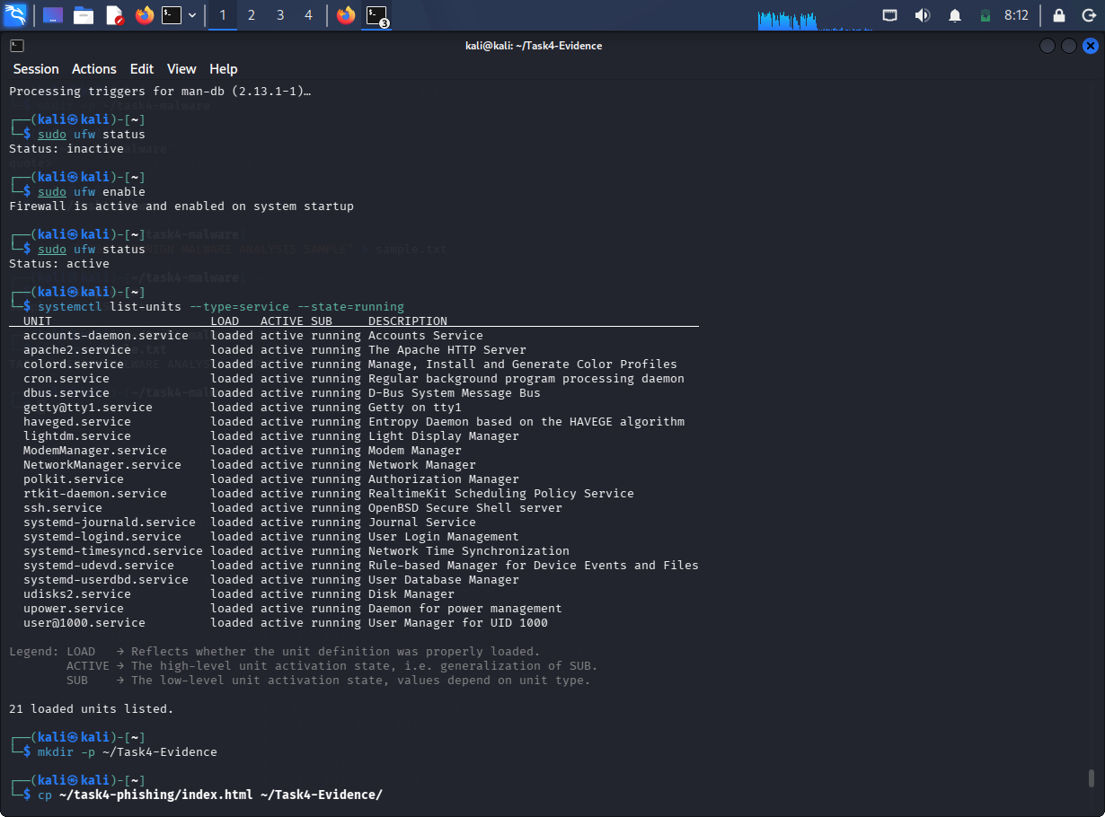
Security Benefit
A firewall can:
- Restrict unwanted network connections.
- Reduce attack surface.
- Control inbound traffic.
- Help prevent unauthorized access.

9.3 Service Review
Running services were reviewed using:
systemctl list-units --type=service --state=running
Unused services should only be disabled after confirming that they are not required by the operating system or installed applications.
Security Benefit
Removing unnecessary services reduces the number of potentially exploitable components exposed on the system.

10. FINDINGS AND MITIGATIONS
Finding | Risk | Recommended Mitigation
Weak passwords | Unauthorized access | Strong passwords + MFA
SSH brute-force possibility | Account compromise | Rate limiting, MFA, SSH keys
Vulnerable services | System compromise | Patch or remove vulnerable services
Unnecessary services | Increased attack surface | Disable after verification
Phishing | Credential theft | Security awareness training
Unpatched software | Exploitation risk | Regular security updates
Unrestricted network access | Unauthorized connections | Firewall rules
Malware | System/data compromise | Endpoint protection and sandbox analysis

11. SECURITY RECOMMENDATIONS
The following security controls are recommended:
- Keep operating systems and applications updated.
- Use strong and unique passwords.
- Enable multi-factor authentication.
- Restrict unnecessary network services.
- Configure firewall rules according to least privilege.
- Monitor authentication logs.
- Conduct regular vulnerability assessments.
- Provide phishing-awareness training.
- Analyze suspicious files in isolated environments.
- Maintain proper security documentation and incident-response procedures.

12. CONCLUSION
Task 4 provided practical exposure to exploitation and system-security concepts in a controlled cybersecurity laboratory environment.
The activities covered the penetration-testing methodology, network scanning, Metasploit Framework, controlled password attacks, phishing-awareness simulation, malware-analysis concepts, and system hardening.
The practical exercises demonstrated how security weaknesses such as weak passwords, vulnerable services, phishing, outdated software, and unnecessary services can increase security risk.
Appropriate mitigations such as strong authentication, security updates, firewall configuration, service minimization, and security awareness can significantly reduce the attack surface.
The Metasploitable2-specific exploitation and reverse-shell requirement requires the separate intentionally vulnerable Metasploitable2 target and should be demonstrated only within the authorized isolated laboratory environment.

13. SCREENSHOT INDEX
Put your screenshots in this order:
No. | Screenshot
1 | Kali IP address
2 | Network configuration
3 | Nmap scan
4 | Metasploit console
5 | Metasploit module/research
6 | Hydra result
7 | John the Ripper result
8 | Phishing-awareness page
9 | Benign malware static analysis
10 | System update
11 | UFW firewall
12 | Running services

